# Bananasplit Rev 7: 3.5mm Input Socket Mode Selection

This note explains how to repurpose the 3.5mm socket on the Banansplit with version 7 PCB **(this PCB is yellow, previous PCB versions were green)**. These instructions do not apply to earlier versions of the device.

Earlier versions of the Bananasplit have the 3.5mm socket wired to act as a MIDI input according to the standard adopted in Novation and Arturia devices. At that time there was no universal standard for the wiring of 3.5mm TRS sockets for MIDI, and other manufacturers (e.g. Korg) had the socket wired differently.

However, in 2018 the MIDI Manufacturers Association (MMA) finally set a standard wiring for the socket and they went with the standard being used by Korg. This table shows the two standards.

|  |  |  |  |
| --- | --- | --- | --- |
|  | 3.5mm Plug  SLEEVE | 3.5mm Plug  RING | 3.5mm Plug  TIP |
| Original Bananasplit (and Novation, Arturia etc) | Ground | Signal | +5V |
| **New MMA Standard** (and Korg, Make Noise etc)  **And Bananasplit v7** | Ground | +5V | Signal |

**Note that this does not change anything about how the larger 5 pin MIDI sockets are wired, that has all remained the same throughout!**

# Output Modes

**We have now revised the Bananasplit PCB to use the MMA wiring for the 3.5mm socket**.

However, we realise that some users might want to use the 3.5mm socket with equipment that uses the same wiring as the original, therefore we designed the PCB so that the polarity can be changed. While this does require the unit to be dismantled and it does need soldering, the procedure should be quite straightforward and not take very long.

**As a bonus we also off the option of using the 3.5mm socket as a pulse clock output instead, so you can use it to sync your Korg Volcas, Pocket Operators, Eurorack etc.**

# Dismantle the Banana Split

Use a 2.5mm hex driver to remove six screws from the front panel and the end panels (do not unscew the bolts on the bottom of the unit)

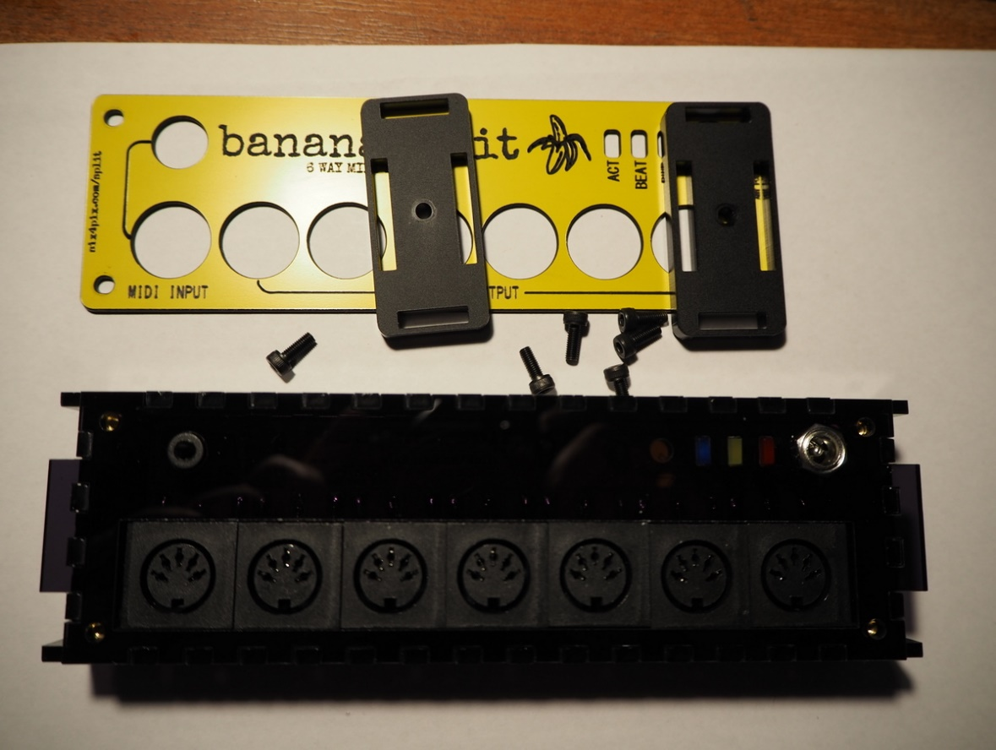

Pull out the side panels and lift up the top panel with PCB attached

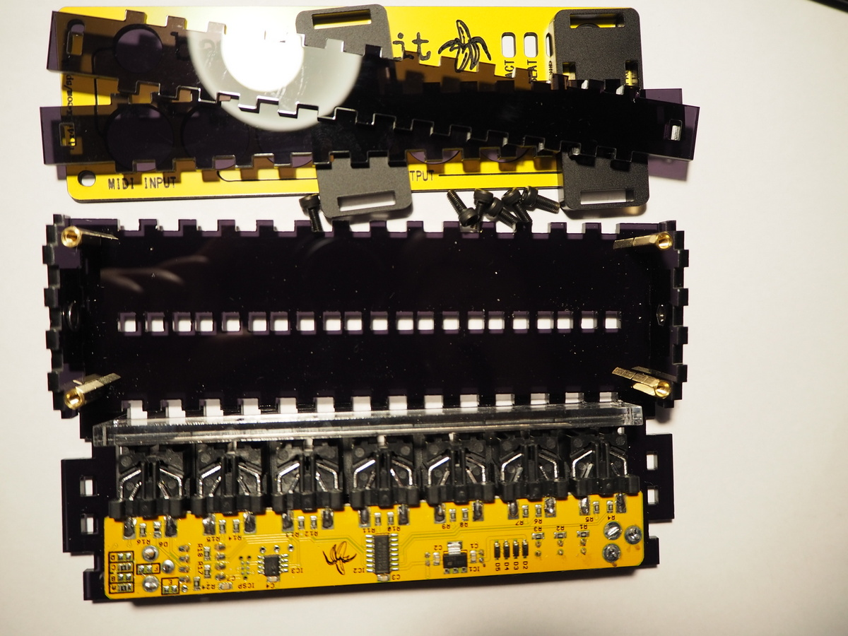

# Remove the Default Settings

Find the pads labelled A and C at the far right of the underside of the board. These are occupied by 0 ohm resistors (small components mated with an “0”)

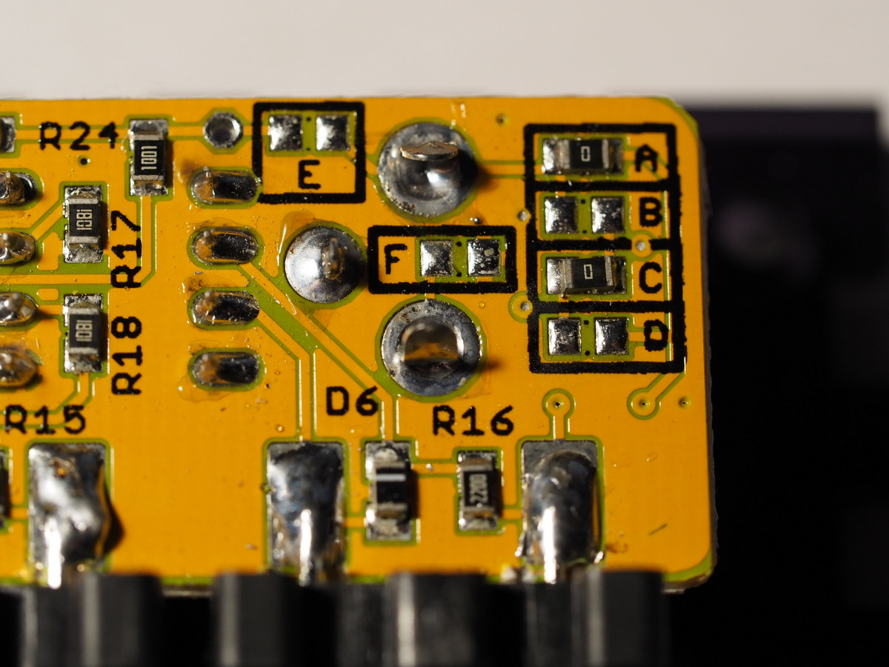

You need to remove these resistors – ideally using some desolder braid, but you can also just lay the edge of the iron tip alongside to heat up both ends of the resistor at once, then carefully slide it off the pads. Be careful not to damage the pads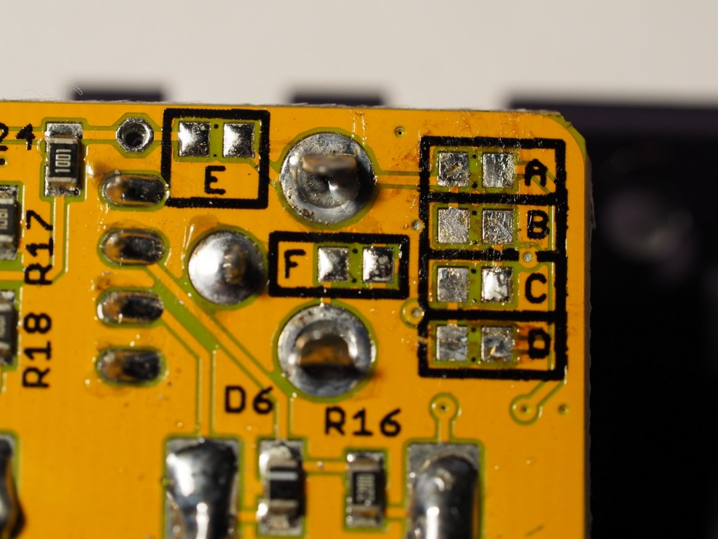

# Select the New Mode

You can then use a blob of solder to join the pads for the mode you need. Only two pads should be joined at any time. The modes are

|  |  |
| --- | --- |
| **Mode** | **Connections** |
| MIDI input, MMA standard (initial factory setting) | Connect across jumper A  Connect across jumper C  B, D, E, F are open |
| MIDI input, Novation/Arturia standard | Connect across jumper B  Connect across jumper D  A, C, E, F are open |
| Pulse clock output | Connect across jumper E  Connect across jumper F  A, B, C, D are open |

Modified for Novation/Arturia standard (B, D bridged)

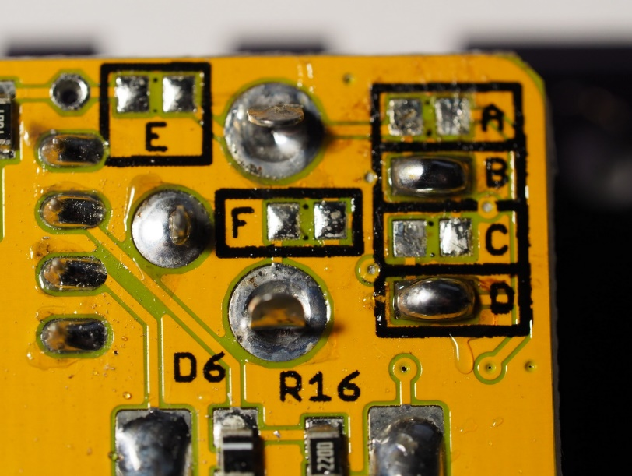

Modified for Pulse clock output (E, F bridged)

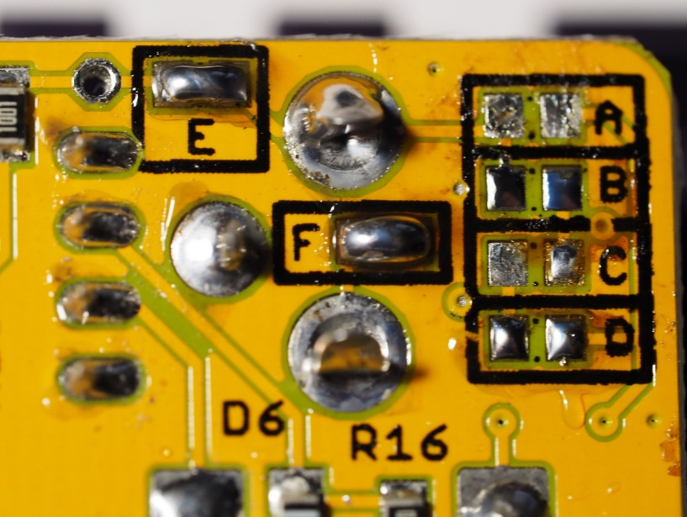

# Reassembling the Unit

When re-assembling, ensure that the flanged nuts on the end panels are on the inside of the case

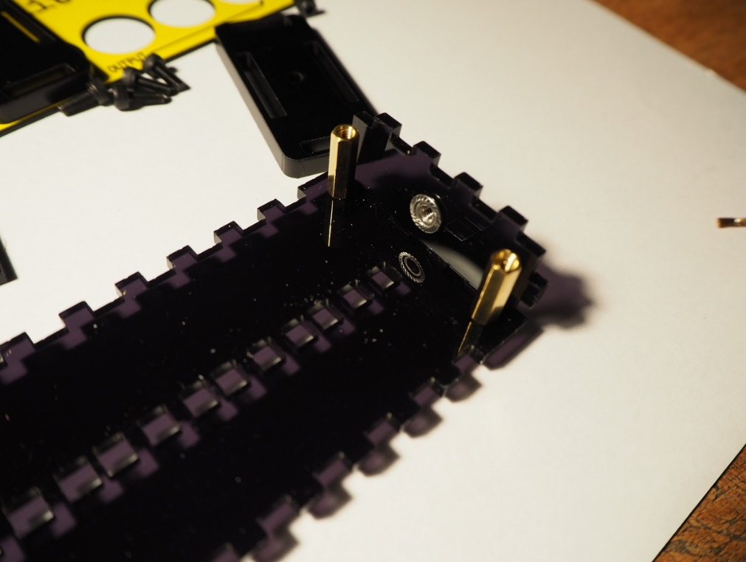

Also avoid over tightening the bolts that hold on the front panel. Doing so can crack the panel. Finger tight is fine.

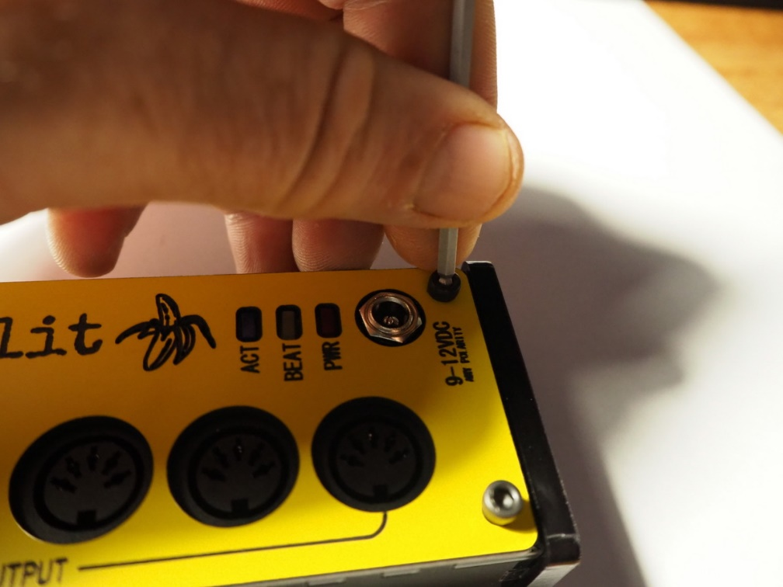

# Selecting Clock Rate

If you configured the socket to act as a clock output, you can change the clock rate by sending a MIDI sysex file to the Banana Split. Once the file is installed, the yellow and blue LEDs will blink rapidly and you will need to turn the Banana Split off and back on again to go back to normal operation.

You can download the sysex files using this link: <https://github.com/hotchk155/banana-split/tree/master/sysex>

The following files are available

|  |  |
| --- | --- |
| sig_8th.syx | One clock pulse per 8th note (Korg volca default) |
| sig_16th.syx | One clock pulse per 16th note (most Eurorack sequencers) |
| sig_24ppqn.syx | One clock pulse per 96th note (DIN SYNC-24) |